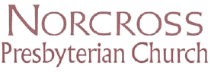
“A place to call home”

Sunday School Classes, Spring 2004

Times Class Place

9:15-9:30 Gathering and Worship Sanctuary

9:30-10-15 Preschool (3 & 4 year olds) Little Rascals
Classroom
9:30-10:15 Elementary (K-5th grade) Busy Bees Classroom
The children will be studying from the Faith Weaver curriculum.

9:30-10:15 Adult Bible Study Covenant Room B
This class will be using the Faith Weaver Curriculum.

9:30-10:15 Kerygma Adult Bible Study Covenant Room A

Kerygma class materials will be used.

9:30-10-15 High School High School Room

Two teachers will lead this group using the Faith Weaver curriculum

9:30-10-15 Middle School Middle School Room

Two teachers will lead this group using the Faith Weaver curriculum

